**CSE2006-MICROPROCESSORS (EMBEDDED LAB)**

**NAME:** O G RAGAVI

**REG NO:** 20BCE1988

**TITLE:** HARDWARE IMPLEMENTATION OF ALP

**EX NO: 9**

**AIM:** To show the hardware implementation of simple ALP programs.

**TOOL USED:** 8086 microprocessor

**STEPS USED:**

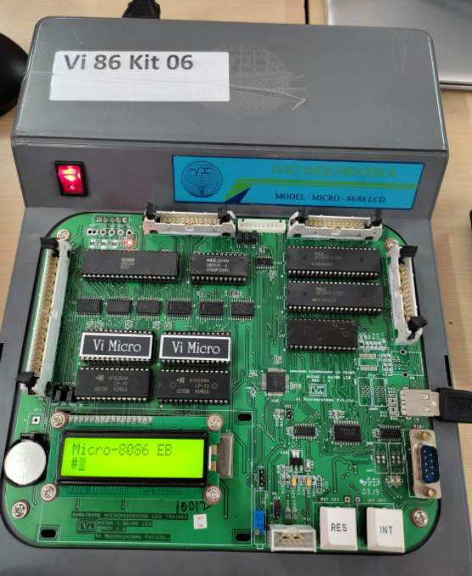

* Connect the keyboard to the usb pin hold provided in the microprocessor.
* Switch on the device.
* Enter A.
* Enter the start address
* Start writing the code thereafter

**1.ADDITION:**

**ALGORITHM:**

* Load the first value to be added in AX register.
* Load the second value to be added in BX register.
* Add both and store in the memory location 2000.
* Terminate the program successfully.

**CODE:( STARTING ADDRESS :1000)**

MOV AX,1111H

MOV BX,2222H

ADD AX, BX

MOV [2000], AX

HLT

**OUTPUT:**

**Lower order bit**

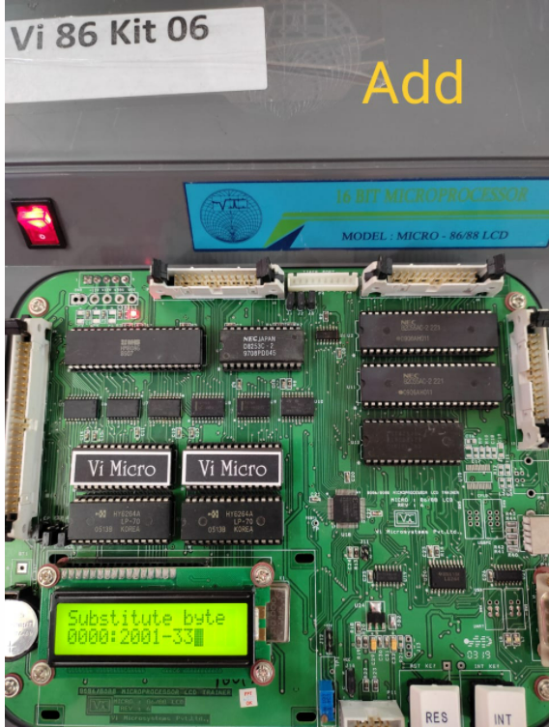

**Higher order bit:**

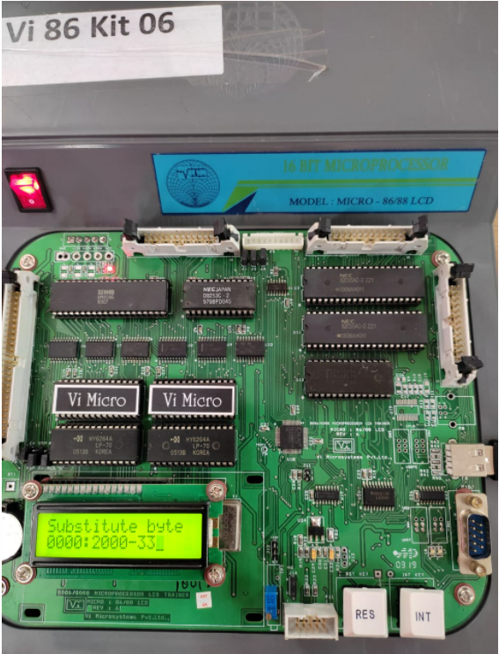

**2.SUBTRACTION:**

**ALGORITHM:**

* Load the first value to be added in AX register.
* Load the second value to be added in BX register.
* Subtract both and store in the memory location 2000.
* Terminate the program successfully.

**CODE:( STARTING ADDRESS :1000)**

MOV AX,2222H

MOV BX,1111H

SUB AX, BX

MOV [2000], AX

HLT

**OUTPUT:**

Lower order bit:

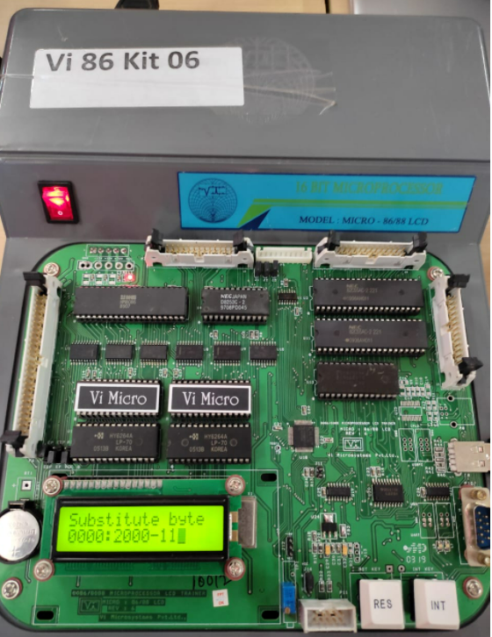

Higher order bit:

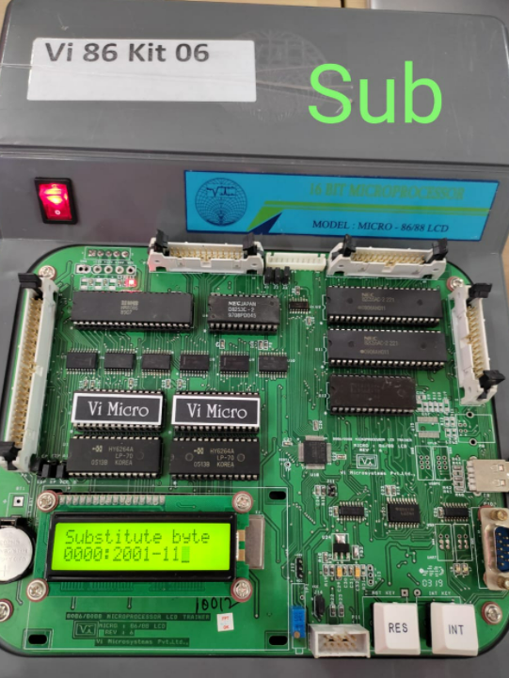

**3.MULTIPLICATION:**

**ALGORITHM:**

* Load the first value to be added in AX register.
* Load the second value to be added in BX register.
* Multiply both and store in the memory location 2000.
* Terminate the program successfully.

**CODE(STARTING ADDRESS 1000):**

MOV AX,1111H

MOV BX,0004H

MUL BX

MOV [2000],AX

HLT

**OUTPUT:**

Lower order bit:

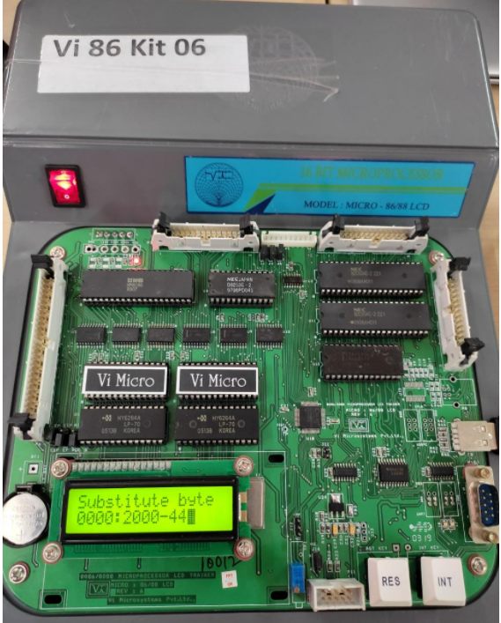

Higher order bit:

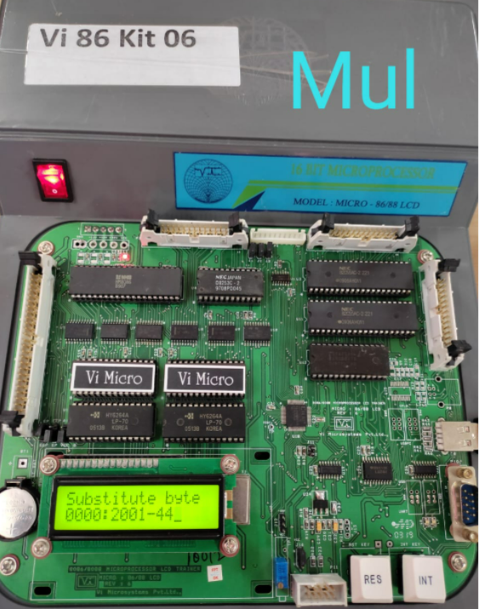

**4.DIVISION:**

**ALGORTIHM:**

* Load the first value to be added in AX register.
* Load the second value to be added in BX register.
* Divide both and store in the memory location 2000.
* Terminate the program successfully.

**CODE:**

MOV AX,2000H

MOV BX,0002H

DIV BX

MOV [2000],AX

HLT

**OUTPUT:**

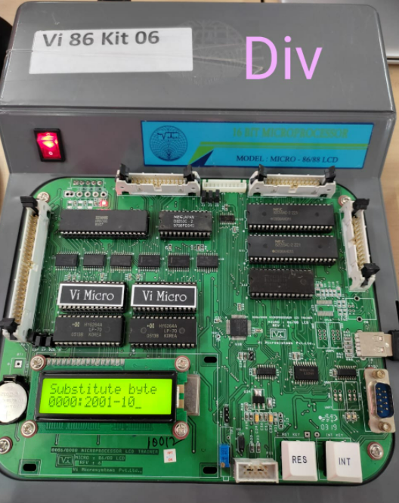

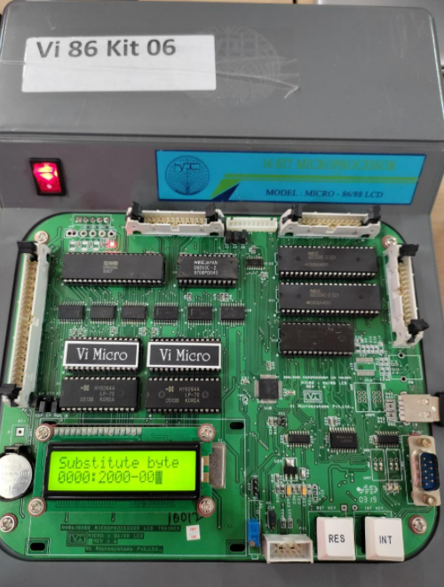

**5.AVERAGE :**

**ALGORTIHM:**

* Load the first value to be added in AX register.
* Start adding the value one by one (the resultant value will be stored in AX -accumulator register).
* Move the ‘n’ values or no of numbers that are added into the BX register.
* Now, divide the resultant added value with the value stored in BX register.

**CODE:**

MOV AX,1000H

ADD AX,2000H

ADD AX,3000H

MOV BX,3H

DIV BX

MOV [2000],AX

HLT

**OUTPUT:**

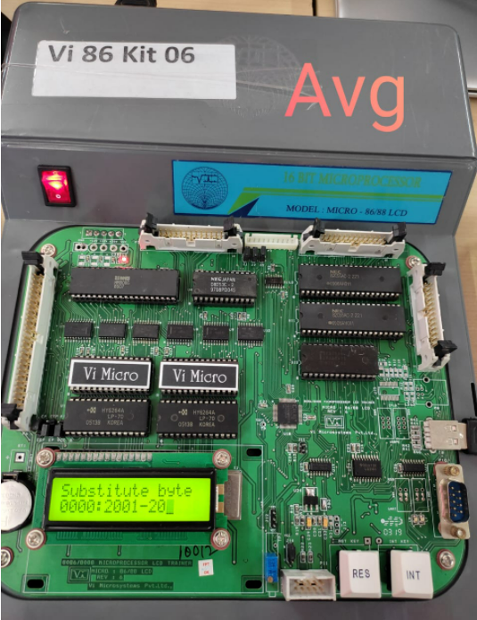

**6.ADD WITH CARRY:**

**CODE with steps:**

Press A and enter

• Enter start address - 1000

• MOV AX,[2000]- Press enter twice

• MOV BX,[2002] - Press enter twice

• MOV CL,00 -Press enter twice

• ADD AX,BX - Press enter twice

• JNC 1050 - Press enter twice

• INC CL - Press enter twice

• MOV [2004],AX - Press enter twice

• MOV [2006], CL - Press enter twice

• HLT - Press enter twice

• Hit Reset button

• Press A

• 100D - Press enter twice

• JNC 1011 - Press enter twice (to make the address correct)

• Hit Reset button

• GO 1000

• SB 2000 11- Press enter

• 2001 11- Press enter

• 2002 22- Press enter

• 2003 - Press enter • GO 1000 • Hit Reset button • SB 2004

**OUTPUT:**

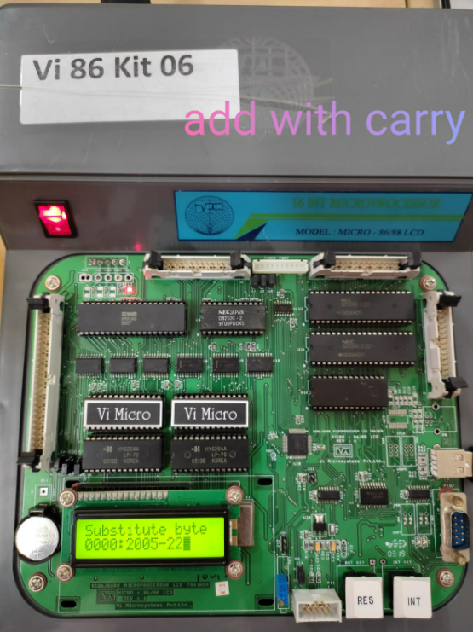

**RESULT:**

Hence, ALP is implemented through hardware.